FLIP, TURN AND SLIDE

KS1 – 2001 Paper
1.
KS1 – 2002 Papers
2.
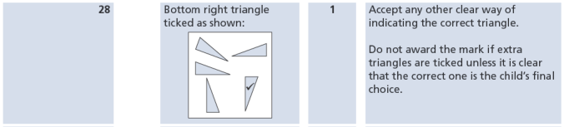
KS1 – 2007 Paper 1
3.
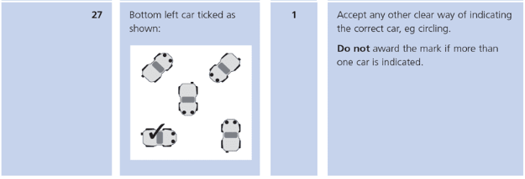
KS1 – 2016 Paper – Reasoning (Second)
4.
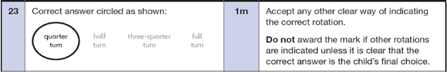
KS1 – 2019 Paper – Reasoning
5.
